2.1
I 8 0 2 0
I 35 4 3 0
I 43 5 3 0
I 8 4 4 4
I 8 5 5 4
I 4 3 0 -20
2.4
Since MIPS includes add immediate and since immediates can be positive or negative, subtract immediate would be redundant.

2.6
sll $t0, $t3, 9 # shift $t3 left by 9, store in $t0
srl $t0, $t0, 15 # shift $t0 right by 15

2.30
sll $a2, $a2, 2 # max i= 2500 * 4
sll $a3, $a3, 2 # max j= 2500 * 4
add $v0, $zero, $zero # $v0 = 0
add $t0, $zero, $zero # i = 0
outer: add $t4, $a0, $t0 # $t4 = address of array 1[i]
lw $t4, 0($t4) # $t4 = array 1[i]
add $t1, $zero, $zero # j = 0
inner: add $t3, $a1, $t1 # $t3 = address of array 2[j]
lw $t3, 0($t3) # $t3 = array 2[j]
bne $t3, $t4, skip # if (array 1[i] != array 2[j]) skip $v0++
addi $v0, $v0, 1 # $v0++
skip : addi $t1, $t1, 4 # j++
bne $t1, $a3, inner # loop if j != 2500 * 4
addi $t0, $t0, 4 # i++
bne $t0, $a2, outer # loop if i != 2500 * 4

The code determines the number of matching elements between the two arrays and returns this number in register $v0.

2.31
Ignoring the four instructions before the loops, we see that the outer loop (which iterates 2500 times) has three instructions before the inner loop and two after. The cycles needed to execute these are 1 + 2 + 1 = 4 cycles and 1 + 2 = 3 cycles, for a total of 7 cycles per iteration, or 2500×7 cycles. The inner loop requires 1 + 2 + 2 + 1 + 1 + 2 = 9 cycles per iteration and it repeats 2500×2500 times, for a total of 9×2500×2500 cycles. The total number of cycles executed is therefore (2500×7) + (9×2500×2500) = 56,267,500. The overall execution time is therefore (56,267,500) / (2×10⁹) = 28 ms. Note that the execution time for the inner loop is really the only code of significance.

2.34
addi $v0, $zero, -1 # Initialize to avoid counting zero word
loop: lw, $v1, 0($a0) # Read next word from source
addi $v0, $v0, 1 # Increment count words copied
sw $v1, 0($a1) # Write to destination
addi $a0, $a0, 4 # Advance pointer to next source
addi $a1, $a1, 4 # Advance pointer to next destination
bne $v1, $zero, loop # Loop if word copied != zero
Bug 1: Count ($v0) is initialized to zero, not –1 to avoid counting zero word.
Bug 2: Count ($v0) is not incremented.
Bug 3: Loops if word copied is equal to zero rather than not equal.

2.37
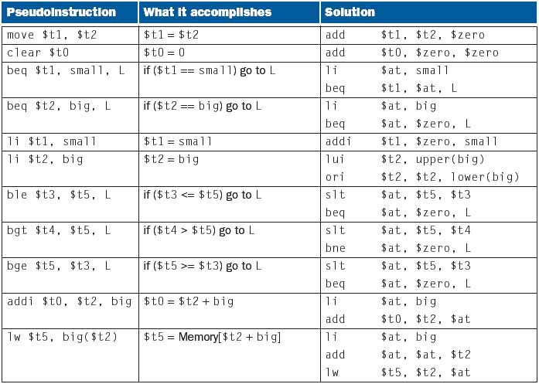
Note: In the solutions, we make use of the li instruction, which should be implemented as shown in rows 5 and 6.

2.38
The problem is that we are using PC-relative addressing, so if that address is too far away, we won’t be able to use 16 bits to describe where it is relative to the PC. One simple solution would be
here: bne $s0, $s2, skip
j there
skip:
…
there: add $s0, $s0, $s0
This will work as long as our program does not cross the 256MB address boundary described in the elaboration on page 98.

